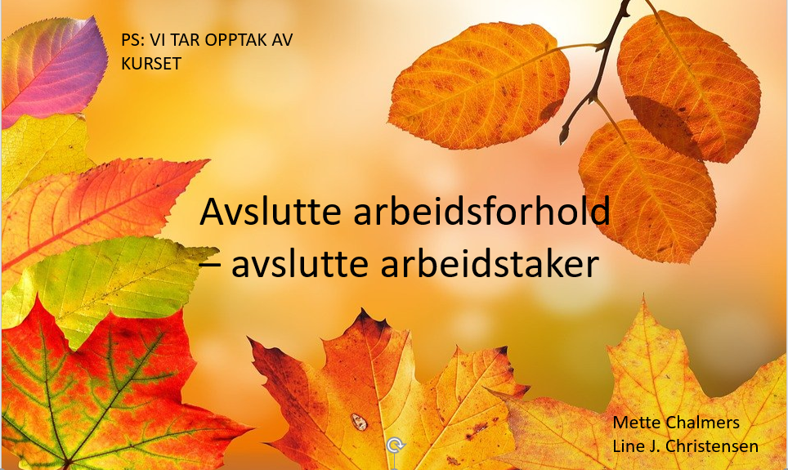

LINK TIL OPPTAK:

https://iktagder-my.sharepoint.com/personal/mette_chalmers_akst_no/_layouts/15/download.aspx?UniqueId=a0ffce54%2D5368%2D49b6%2Db8eb%2Ddee4d7d9d0c8

